

MALLAREDDY VISHWAVIDYAPEETH
DEEMED TO BE UNIVERSITY, HYDERABAD



MALLAREDDYTECHNICALCAMPUS
A CONSTITUENT UNIT OF MALLA REDDY VISHWAVIDYAPEETH

SMART ROUTE FINDER

BATCH 2025 -2029

SMART ROUTE FINDER
Multi-Path Route Optimization & Explainability Engine
Design and Analysis of Algorithms (DAA) Project Documentation

Intelligent Shortest Path Optimization

An algorithm-driven route engine that compares multiple paths, computes optimal travel cost, visualizes alternatives, and explains why the selected route is optimal.

PROJECT REPORT

Project Area | Details
Domain | Smart Transportation / Navigation / Logistics
Core Algorithms | Dijkstra, A* Search, Floyd-Warshall
Backend | Python 3.10+ / Flask 3.x
Frontend | HTML5, CSS3, Leaflet.js
Database | SQLite3
Testing | 41 unit and integration tests
License | MIT

Team Member
Chetala Venkata Teja
Patlolla Madhusudan Reddy
Khandare Hansika
Kathi Sai Madhuhasini

Prepared for academic/project documentation 2026

Abstract & Introduction
Smart Route Finder is a Design and Analysis of Algorithms project focused on multi-path route optimization and explainability. The system models a geographic road network as a weighted graph and applies three foundational shortest-path algorithms—Dijkstra’s Algorithm, A* Search, and Floyd-Warshall—to compute and compare routes between locations.
The central purpose is not only to identify a minimum-cost route but also to make the algorithmic reasoning visible. The system reports route cost, estimated travel time, explored nodes, execution time, alternative routes, and an explanation of the principle responsible for optimality. This creates a bridge between theoretical DAA concepts and a practical navigation-oriented application.

Introduction
Modern navigation and transportation systems can be represented using graph structures. Physical junctions become vertices, road segments become edges, and measurable properties such as distance or estimated travel time become edge weights. Once the road network is modeled in this form, shortest-path algorithms can systematically determine efficient paths.
The Smart Route Finder implementation uses live graph computations rather than hardcoded route outputs. Its design combines a Flask REST backend, a browser-based interface, an interactive Leaflet map, an algorithms engine, and SQLite3 persistence. The README describes a network of 15 landmark junctions across the Cyberabad IT Corridor and Financial District.

Project Motivation
- Connect algorithm theory with a realistic geographic routing problem.
- Compare greedy, heuristic, and dynamic-programming approaches.
- Expose internal algorithm states so users can understand how routes are produced.
- Quantify the trade-off between optimality, explored nodes, and computation time.

Problem Statement, Objectives & Scope

Problem Statement
The project aims to build an intelligent route engine that compares multiple paths between locations in a weighted geographic network, calculates the strictly minimal travel cost, discovers competitive alternatives, and explains mathematically and practically why the selected route is optimal compared with alternatives.
The implementation benchmarks Dijkstra’s Algorithm, A* Search, and Floyd-Warshall on live graph topologies. The system is designed so that routes, costs, and exploration metrics are generated from actual algorithm execution rather than fabricated outputs.

Objectives
- Model a geographic road network as a weighted graph G = (V, E, W).
- Compute exact shortest paths using Dijkstra’s Algorithm.
- Use an admissible Haversine heuristic to provide goal-directed A* search.
- Compute all-pairs shortest paths using Floyd-Warshall dynamic programming.
- Generate and quantify secondary and tertiary route alternatives.
- Expose algorithm-specific internal states for educational explainability.
- Benchmark execution time, explored nodes, and theoretical complexity.
- Handle edge cases such as identity queries, unreachable destinations, equal-cost ties, and disconnected graphs.

Scope
The scope covers graph-based route optimization, shortest-path computation, alternative route generation, algorithm visualization, REST API interaction, SQLite3 history, automated verification, and comparative benchmarking. The project is an algorithmic routing engine and does not claim to implement the complete traffic, map-matching, or road-condition capabilities of a commercial navigation platform.

Features & Functional Requirements

Major Features
  - No hardcoded or fake route results; outputs are calculated from algorithm executions.
  - Real-world geographic coordinate network with 15 landmark junctions.
  - Dynamic generation of secondary and tertiary alternatives with quantified detours.
  - DAA optimality explanation based on greedy choice, admissible heuristic consistency, or dynamic-programming substructure.
  - A* search-state inspector displaying g(n), h(n), f(n), and parent pointers.
  - Dijkstra settlement-order inspector showing min-heap extraction and settled costs.
  - Interactive Floyd-Warshall distance matrix.
  - Head-to-head benchmark showing execution times, nodes expanded, operations, and theoretical complexity.
  - Edge-case handling for S=T, unreachable destinations, equal-cost ties, and disconnected graphs.

Functional Requirements

Requirement | Description | Expected Behavior
Route Input | Select source and destination junctions. | Accept valid vertex IDs or map selections.
Algorithm Selection | Choose Dijkstra, A*, or Floyd-Warshall. | Execute the selected algorithm.
Shortest Route | Calculate an optimal path. | Return vertex sequence and total cost.
Travel Metrics | Show distance and estimated time. | Present km and minutes.
Exploration Metrics | Count explored states. | Return visited/expanded node count.
Alternatives | Find competitive detours. | Return secondary and tertiary paths with overhead.
Explainability | Explain why the chosen route is optimal. | Display DAA principle and comparison.
Benchmark | Compare all three algorithms. | Return timing and exploration metrics.
History | Persist route queries. | Store audit trail in SQLite3.

Non-Functional Requirements
  - Correctness and repeatability of algorithmic calculations.
  - Clear visual feedback through an interactive web interface.
  - Maintainable separation of frontend, backend, algorithm engine, database, and tests.
  - Responsive API-based communication using JSON.

Algorithms & Methodology

Graph Modeling
The system represents the road network as G = (V, E, W). Vertices represent intersections, landmarks, and transit junctions. Every vertex is associated with latitude and longitude coordinates. Edges represent physical road segments, and their non-negative weights represent road distance and estimated transit time.
The non-negative weight requirement is important because Dijkstra’s Algorithm assumes w(u,v) ≥ 0. The geographic model also supports a straight-line lower bound used by A*. Because physical roads twist and turn, the actual road distance is bounded below by the spherical straight-line distance.

Routing Methodology
- Receive source, target, algorithm key, and graph topology.
- Initialize the selected algorithm using the graph’s vertices, edges, and weights.
- Execute shortest-path computation and maintain predecessor information.
- Reconstruct the route from the destination back to the source.
- Calculate route distance, estimated travel time, explored nodes, and execution time.
- Generate competitive alternative routes and quantify detour overhead.
- Produce an algorithm-specific optimality explanation.
- Return the result to the frontend as JSON for visualization.

Input
The documented input includes a source vertex, target vertex, algorithm key, and graph topology containing GPS coordinates and weighted adjacency lists.

Output
The documented output includes the optimal vertex sequence, shortest travel cost, estimated travel time, explored-node count, execution duration, alternative routes, and an optimality explanation.

Algorithms & Methodology — Dijkstra's Algorithm

Overview
Dijkstra’s Algorithm is used for exact single-source shortest-path computation on graphs with non-negative edge weights. It follows a greedy strategy: at each step, the unsettled vertex with the smallest currently known distance is selected and settled.

Working Principle
- Initialize every distance to infinity and the source distance to zero.
- Insert the source into a min-priority queue.
- Extract the vertex with the smallest tentative distance.
- Skip stale queue entries whose distance is larger than the current recorded distance.
- Settle the extracted vertex.
- If the target is settled, terminate early.
- Relax each outgoing edge and update distance and predecessor when a shorter route is found.
- Reconstruct the path using predecessor pointers.

Pseudocode
Algorithm Dijkstra(Graph G, Vertex source, Vertex target): dist[v] ← ∞ for all v V
dist[source] ← 0
pred[v] ← null for all v V
PQ ← PriorityQueue containing (0, source) visited ← empty set

while PQ is not empty:
(current_dist, u) ← PQ.extract_min() if current_dist > dist[u]: continue visited.add(u)

if u == target: break

for each neighbor v of u with edge weight w: if dist[u] + w < dist[v]:
dist[v] ← dist[u] + w pred[v] ← u PQ.insert((dist[v], v))

return ReconstructPath(pred, target), dist[target]

Optimality Basis
The README attributes Dijkstra’s guarantee to the greedy choice property: once a vertex is extracted with the smallest distance, its distance is final under non-negative edge weights. This makes Dijkstra an appropriate exact baseline for comparing other approaches.

Algorithms & Methodology — A* Search

Overview
A* is an informed, goal-directed shortest-path algorithm. Instead of expanding equally in all directions, it combines the accumulated path cost g(n) with a heuristic estimate h(n) of the remaining cost. The evaluation function is f(n) = g(n) + h(n).

Haversine Heuristic
The project uses the Haversine spherical distance between a current geographic vertex and the target as the heuristic. The README describes this as an admissible and monotone (consistent) lower bound for the road-distance setting used by the application.

Pseudocode
Algorithm AStar(Graph G, Vertex source, Vertex target): g_score[v] ← ∞ for all v V
g_score[source] ← 0 f_score[v] ← ∞ for all v V
f_score[source] ← Haversine(source, target)

OpenSet ← PriorityQueue containing (f_score[source], source)
ClosedSet ← empty set pred[v] ← null for all v V

while OpenSet is not empty:
(current_f, u) ← OpenSet.extract_min() if u ClosedSet: continue ClosedSet.add(u)

if u == target: break

for each neighbor v of u with edge weight w: if v ClosedSet: continue
tentative_g ← g_score[u] + w

if tentative_g < g_score[v]: pred[v] ← u
g_score[v] ← tentative_g
f_score[v] ← g_score[v] + Haversine(v, target) OpenSet.insert((f_score[v], v))

return ReconstructPath(pred, target), g_score[target]

Why A* Is Useful Here
The README reports that A* can reduce node expansions relative to blind Dijkstra exploration while preserving the identical optimal distance when the heuristic is admissible and consistent. The documented implementation therefore provides both efficiency and an educational view of heuristic search.

Algorithms & Methodology — Floyd-Warshall

Overview
Floyd-Warshall is a dynamic-programming algorithm for the all-pairs shortest-path problem. Instead of solving one source-target pair directly, it progressively permits more vertices to act as intermediate points.

Dynamic Programming Recurrence
For intermediate set k, the core update is: D[i][j] = min(D[i][j], D[i][k] + D[k][j]). If routing through k provides a smaller distance than the current value, the matrix is updated and the next-hop information is adjusted.

Pseudocode
Algorithm FloydWarshall(Graph G):
Let D be a |V| × |V| matrix initialized to ∞
Let Next be a |V| × |V| matrix initialized to null

for each vertex v V:
D[v][v] ← 0

for each edge (u, v) E with weight w: D[u][v] ← w
Next[u][v] ← v

for k from 1 to |V|: for i from 1 to |V|:
for j from 1 to |V|:
if D[i][k] + D[k][j] < D[i][j]:
D[i][j] ← D[i][k] + D[k][j] Next[i][j] ← Next[i][k]

return D, Next

Role in the System
Floyd-Warshall acts as an all-pairs precomputation engine. Once its complete distance matrix has been computed, a route-distance lookup between two vertices can be resolved from the matrix in constant lookup time, while the precomputation itself requires cubic time.

Algorithms & Methodology — Comparative Method

Algorithm Comparison

Algorithm | Paradigm | Directionality | Heuristic | Scope
Dijkstra | Greedy | Uninformed / radial | No | Single-source one-to-all
A* | Informed heuristic search | Goal-directed | Yes, Haversine | Single-pair point-to-point
Floyd-Warshall | Dynamic programming | Intermediate-set based | No | All-pairs any-to-any

Methodological Comparison
Dijkstra provides the exact baseline for non-negative weighted graphs. A* uses the same graph model but introduces geographic knowledge through the Haversine heuristic. Floyd-Warshall takes a different perspective by computing all-pairs distances through dynamic programming.
The project therefore demonstrates three distinct DAA paradigms on one routing problem: greedy optimization, heuristic search, and dynamic programming. This makes the application suitable for illustrating not only shortest-path results but also differences in computational strategy.

Alternative Route Methodology
The README specifies dynamic multi-route generation with secondary and tertiary alternatives. Alternatives are presented with additional distance and percentage detour values and, where available, diversion reasons. The purpose is to show that a shortest route can be compared against viable non-optimal paths rather than displayed in isolation.

Explainability Methodology
The optimality explanation is tied to the governing algorithmic principle. Dijkstra uses the greedy choice property; A* relies on an admissible and consistent heuristic; Floyd-Warshall relies on dynamic-programming substructure. This explanation layer is a defining feature of the project.

Technologies & Implementation — Web Interface & Route Planning
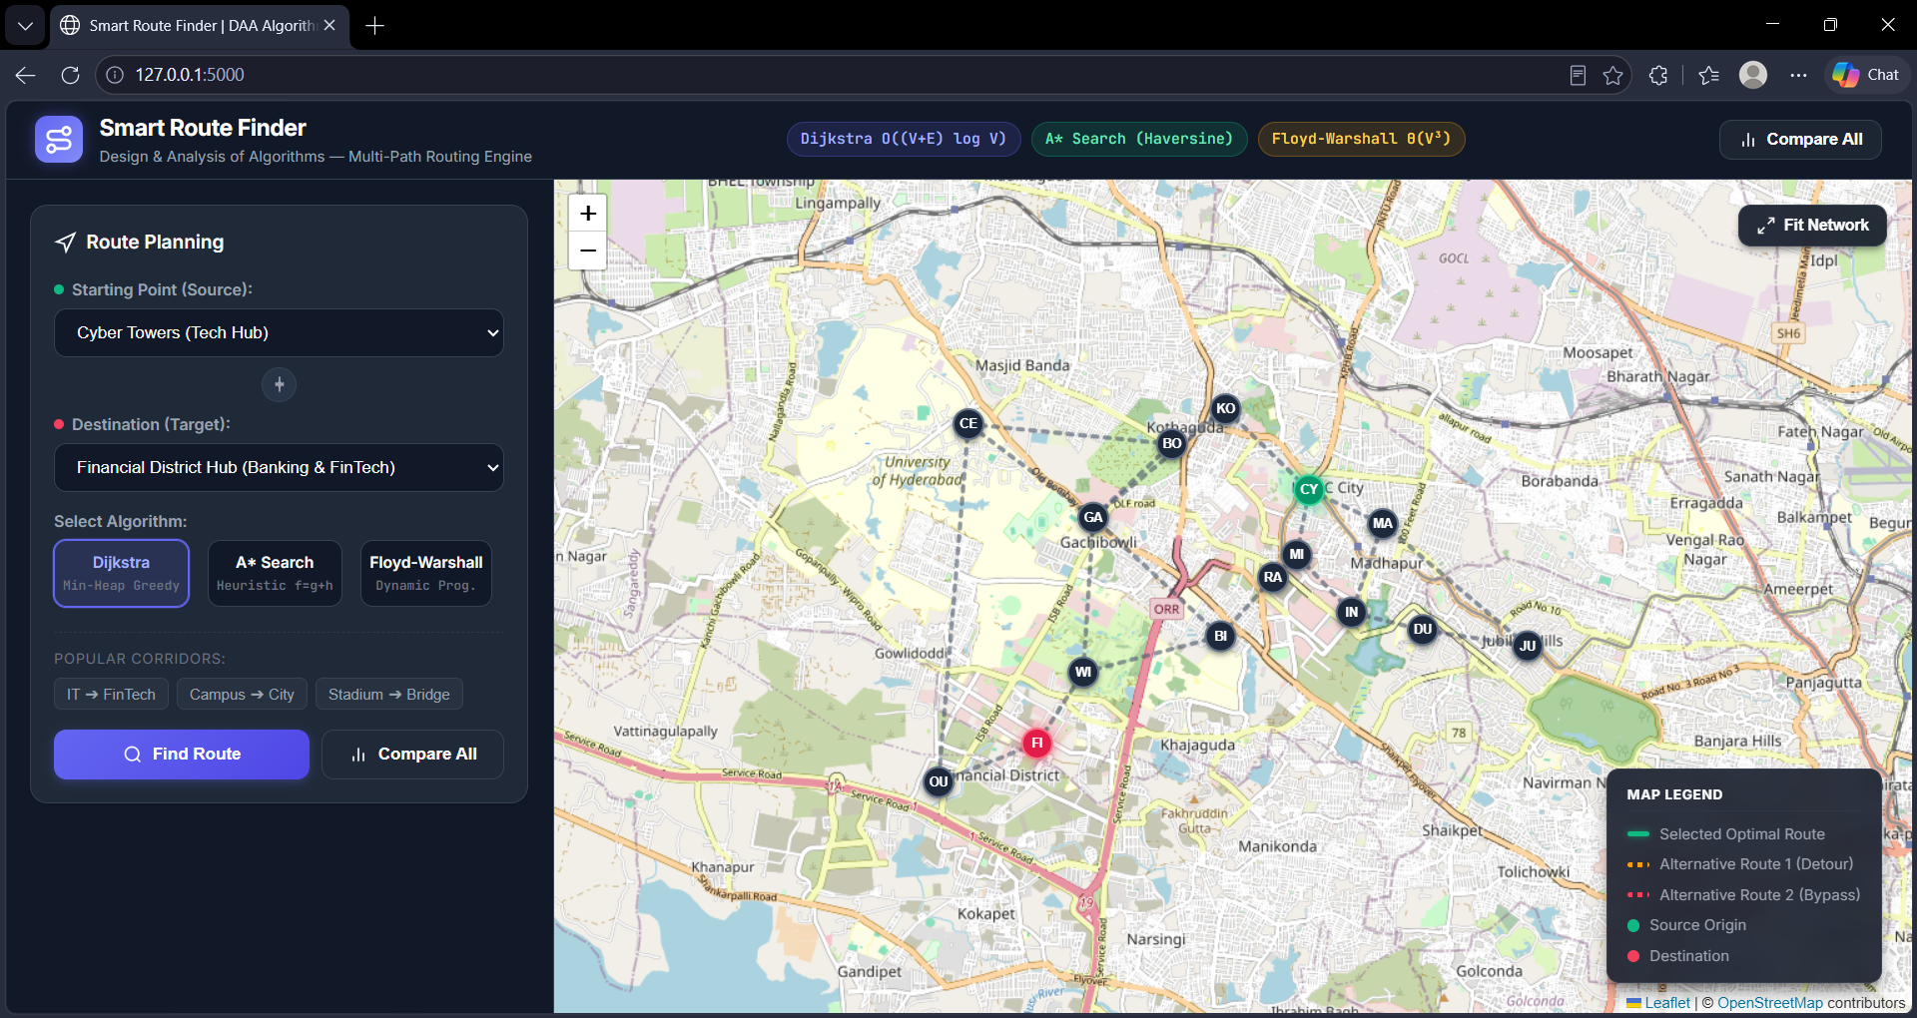
Figure 12.1: Route planning interface showing source, destination, Dijkstra selection and the interactive map.
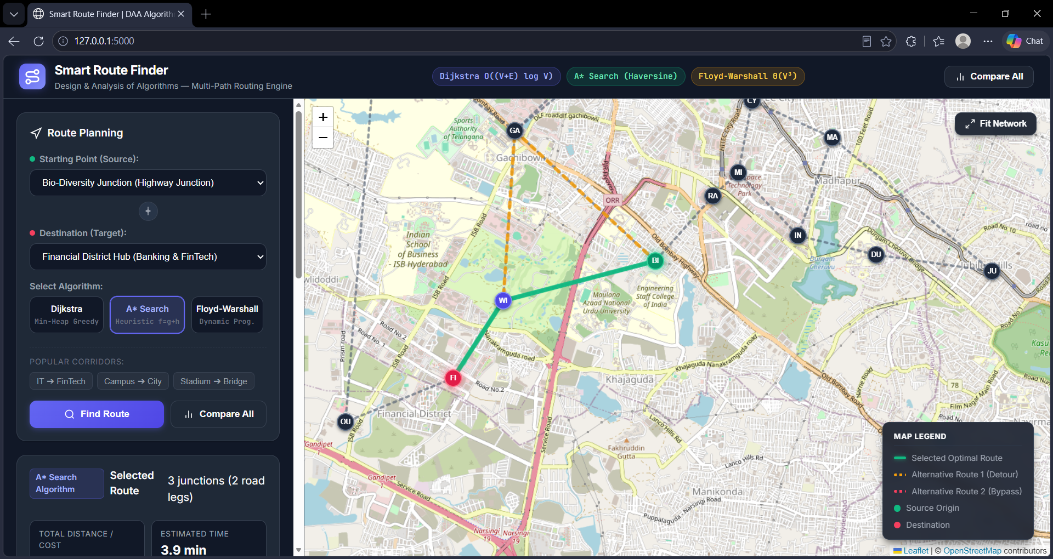
Figure 12.2: A* route planning view showing the selected route, geographic nodes and map-based visualization.
The interface allows the user to select a source, destination and routing algorithm before calculating a route. The Leaflet map visualizes the selected path, alternative routes and geographic nodes for clear route comparison. The dashboard connects the frontend with the DAA engine and presents algorithm-specific routing results and metrics.

Technologies & Implementation — Graph and API Design

Graph Engine
The algorithms engine contains a graph class responsible for geographic mathematics and Haversine calculations. It coordinates the Dijkstra module, A* module, Floyd-Warshall dynamic-programming matrix, alternative-route generator, and DAA optimality explainer.

REST API

Endpoint | Method | Function
/api/graph | GET | Returns graph vertices, GPS coordinates, edges, and geographic bounds.
/api/route | POST | Computes selected route, alternatives, and DAA explanation.
/api/compare | POST | Executes the three algorithms concurrently and returns benchmark data.
/api/history | GET | Returns the audit trail of route queries stored in SQLite3.

Data Flow
- User selects source and destination on the frontend.
- The frontend sends the route configuration to the Flask REST API.
- The backend validates the requested locations and algorithm.
- The graph engine executes the selected shortest-path method.
- Alternative routes and explanation data are generated.
- Metrics and route information are serialized as JSON.
- The frontend renders the route and algorithm-specific visualization.
- The query can be retained in SQLite3 history.

Installation
git clone https://github.com/your-username/smart-route-finder.git cd smart-route-finder
pip install -r requirements.txt

Execution
python run.py # Open:
http://127.0.0.1:5000

Technologies & Implementation — Algorithm Internals

A* State Inspector
The A* visualizer exposes the search state as a table containing g(n), h(n), f(n) = g(n) + h(n), and parent pointers. This makes the relationship between accumulated route cost and estimated remaining cost visible during exploration.

State Field | Meaning
g(n) | Known cost from the source to node n.
h(n) | Haversine heuristic estimate from n to the destination.
f(n) | Combined priority value g(n) + h(n).
Parent | Predecessor used to reconstruct the route.

Dijkstra Settlement Inspector
The Dijkstra visualizer displays the sequence of vertices extracted from the min-heap and their permanent distances d[u]. This directly demonstrates the greedy settlement process.

Floyd-Warshall Matrix
The Floyd-Warshall visualizer displays the complete |V| × |V| shortest-distance matrix. The active source row and destination cell can be highlighted so that the user can connect a particular route query to the all-pairs dynamic-programming result.

Benchmarking
The comparison interface executes the three algorithms and reports execution time, explored nodes, operations, and theoretical complexity. The benchmark is intended to show how algorithmic design affects exploration and computation on the same graph.

Edge Handling
- Identity query where source equals target returns a zero-cost route.
- Unreachable destinations are reported as not found rather than fabricating a route.
- Invalid locations produce parameter errors.
- Equal-cost routes support tie-breaking and parallel corridor detection.
- Small and larger graph topologies are included in testing.

Results, Testing & Performance

Testing Strategy
The README documents an automated test suite containing 41 unit and integration tests. The suite covers edge cases, graph topologies, algorithmic proofs, and randomized verification intended to reduce the risk of hardcoded or inconsistent outputs.

Test Categories

Category | Verification Focus
Normal routes | Optimal path discovery across transit pairs.
Alternatives | Edge-penalty routing and path diversity.
Identity routing | Source = destination produces zero-cost behavior.
Unreachable destination | Disconnected graph returns found=False and cost=None.
Invalid locations | HTTP 400 parameter handling.
Equal-cost routes | Tie-breaking and parallel corridor detection.
Different weights | Micro-decimal and large highway distances.
Small graphs | Triangles, chains, and diamond shortcuts.
Larger graphs | 36-node grid and Manhattan-distance validation.
A* heuristic | Admissibility check h(n) ≤ d*(n, goal).
Floyd-Warshall | All-pairs distances match Dijkstra.
Randomized graphs | No hardcoded results; randomized float weights.

Test Execution
python -m unittest discover tests

python -m unittest -v tests/test_engineer_suite.py

Results, Testing & Performance — Experimental Results

Sample Query
The documented experimental query is from Cyber Towers to Financial District Hub. All three algorithms identify the same optimal route in the README’s sample result.

Metric | Dijkstra | A* | Floyd-Warshall
Path | CYBER_TOWERS → MINDSPACE → RAIDURG_METRO → BIODIVERSITY_JN → WIPRO_CIRCLE → FINANCIAL_DISTRIC T | CYBER_TOWERS → MINDSPACE → RAIDURG_METRO → BIODIVERSITY_JN → WIPRO_CIRCLE → FINANCIAL_DISTRIC T | CYBER_TOWERS → MINDSPACE → RAIDURG_METRO → BIODIVERSITY_JN → WIPRO_CIRCLE → FINANCIAL_DISTRIC T
Optimal path cost | 7.1 km | 7.1 km | 7.1 km
Nodes explored | 10 | 6 (40% pruned) | 15 (V³ = 3375 iterations)
Execution time | 0.08 ms | 0.09 ms | 2.45 ms (lookup 0.01 ms)
Optimality verification | Verified | Verified | Verified

Alternative Routes

Alternative | Route Description | Detour
Alternative 1 | Botanical Garden Bypass | 7.9 km (+0.8 km / +11.3%)
Alternative 2 | Outer Ring Road Tollway | 9.8 km (+2.7 km / +38.0%)

Interpretation
The sample demonstrates that the three methods can agree on the same optimal distance while exhibiting different computational behavior. A* explores fewer nodes in this query, while Floyd-Warshall performs an all-pairs computation and therefore has a larger up-front workload but supports subsequent matrix lookups.
These values are the sample experimental results documented in the README; they should be understood as measurements for the stated test query and implementation rather than universal performance guarantees.

Results, Testing & Performance — Complexity Analysis

Complexity Table

Algorithm | Best Case | Average Case | Worst Case | Space
Dijkstra (binary min-heap) | O((V+E) log V) | O((V+E) log V) | O((V+E) log V) | Θ(V)
A* | O(E) | O(E) with tight heuristic | O((V+E) log V) | Θ(V)
Floyd-Warshall | Θ(V³) | Θ(V³) | Θ(V³) | Θ(V²)

Dijkstra Analysis
The documented complexity derives from extracting minimum-priority vertices and relaxing graph edges using a binary heap. The README summarizes the total as O((V + E) log V). The space requirement is documented as Θ(V) for the algorithm’s working structures.

A* Analysis
The README gives an idealized best case of O(E) when the heuristic is sufficiently tight and states that the worst-case complexity matches the Dijkstra-style bound. Its space complexity is Θ(V). The actual number of expanded nodes depends on graph structure and heuristic quality.

Floyd-Warshall Analysis
The three nested loops over k, i, and j perform Θ(V³) work. The algorithm maintains a V × V distance matrix and next-hop matrix, giving Θ(V²) space.

Performance Perspective
The project uses multiple algorithms because no single computational strategy has the same strengths for every routing workload. Single-pair queries can benefit from goal-directed search, exact single-source routing can use Dijkstra, and repeated any-to-any queries can justify an all-pairs precomputation approach.

Results, Testing & Performance — Verification & Reliability

Correctness Verification
The testing suite validates the relationship between independent algorithm implementations. In particular, Floyd-Warshall all-pairs distances are checked against Dijkstra results across the network. A* heuristic admissibility is checked against shortest-path distances.

Reliability Measures
- Randomized graph topology tests reduce dependence on fixed examples.
- Micro-decimal edge weights test numerical handling.
- Grid meshes validate shortest paths on larger structured graphs.
- Disconnected graphs verify failure behavior.
- Equal-cost routes verify tie handling.
- Identity queries verify the boundary condition S = T.
- API-level invalid-location tests verify input validation.
- No-hardcoded-result tests verify that output changes with graph topology and weights.

Performance Metrics
The system records wall-clock execution duration in milliseconds and counts explored or visited nodes. For benchmarking, it can also expose operations and theoretical complexity. These metrics allow the user to compare actual behavior with the asymptotic properties studied in DAA.

Important Interpretation
Execution time measurements are implementation- and environment-dependent. Asymptotic complexity describes how resource requirements scale with input size; it should not be treated as a guarantee that one algorithm will always produce the smallest measured millisecond value on every graph.

Conclusion, Future Scope & References

Conclusion
Smart Route Finder demonstrates how foundational Design and Analysis of Algorithms concepts can be applied to a practical geographic routing problem. By integrating Dijkstra’s greedy shortest-path algorithm, A* informed search, and Floyd-Warshall dynamic programming into a common engine, the project provides both route computation and comparative algorithmic insight.
The project goes beyond displaying a path: it reports distance, estimated time, exploration counts, execution time, alternative routes, and algorithm-specific reasoning. The 41-test suite further supports verification of normal routes, edge cases, graph structures, heuristic admissibility, and cross-algorithm consistency.

Future Scope
- Extend the graph with larger and continuously updated road networks.
- Integrate live traffic or time-dependent edge weights.
- Support additional routing objectives such as toll minimization or fuel-aware routing.
- Introduce bidirectional search and additional heuristic strategies for comparison.
- Improve alternative-route diversity and route similarity constraints.
- Add richer historical analytics from stored route queries.
- Expand deployment architecture for larger workloads and concurrent users.
- Provide additional visualization of algorithm execution step-by-step.

References
- Project README: Smart Route Finder — Design and Analysis of Algorithms (DAA) — Multi-Path Route Optimization & Explainability Engine.
- Python documentation and runtime environment information as specified by the project prerequisites.
- Flask framework documentation referenced by the project technology stack.
- Leaflet.js as the interactive geographic map layer specified by the project.
- Project source code, tests, requirements, and LICENSE as referenced in the README.

Appendix A — Detailed System Workflow

End-to-End Workflow
- Application startup initializes the Flask server and makes the web interface available at the local address.
- The frontend loads the graph data through the graph endpoint.
- Graph vertices and geographic coordinates are made available to the map layer.
- The user selects a source junction and destination junction.
- The user chooses Dijkstra, A*, or Floyd-Warshall.
- The route request is sent to the Flask backend through the REST API.
- The backend passes the request to the algorithms engine.
- The selected algorithm computes shortest-path information.
- The route is reconstructed using predecessor or next-hop information.
- Alternative paths are generated and their detours are quantified.
- Execution metrics and the DAA explanation are assembled.
- The result is returned as JSON.
- The frontend renders the route, metrics, alternatives, and explanation.
- The query may be stored in SQLite3 for history.

Architecture Summary
The workflow maintains a clean separation of concerns: presentation is handled by the frontend, request coordination by Flask, mathematical routing by the algorithms engine, and query persistence by SQLite3. This separation supports testing and future extension.

Appendix B — Pseudocode & Mathematical Notes

Shortest-Path Concepts
For a route P = (v0, v1, …, vk), its accumulated cost is the sum of the edge weights along the route. The shortest-path objective is to find a path whose total cost is minimal among all valid source-to-target paths.

Dijkstra Relaxation
For an edge (u, v) with weight w, relaxation tests whether dist[u] + w is smaller than the current dist[v]. If it is, dist[v] is replaced and pred[v] is set to u.

A* Evaluation
A* prioritizes states using f(n) = g(n) + h(n). Here, g(n) is the known cost from the source, while h(n) is the Haversine estimate from the current vertex to the target.

Admissibility Condition
The README states the heuristic condition as h(n) ≤ d*(n, goal), where d* is the true shortest remaining distance. This means the heuristic does not overestimate the remaining cost in the modeled setting.

Floyd-Warshall Recurrence
At each intermediate vertex k, the algorithm compares the current path from i to j with the path that goes from i to k and then from k to j. The smaller value is retained.

Geographic Lower Bound
The README describes the straight-line spherical distance as a lower bound for physical road distance. This relationship is the foundation for the project’s Haversine heuristic.

Appendix C — Installation, Testing & Operational Checklist

Prerequisites
- Python 3.10, 3.11, 3.12, or 3.13.
- Pip package manager.
- Project source code and requirements file.
- A modern web browser for the frontend.

Installation Checklist
- Clone the repository.
- Change into the project directory.
- Install dependencies using requirements.txt.
- Start the application with python run.py.
- Open http://127.0.0.1:5000 in a browser.

Testing Checklist
- Run the complete unittest discovery command.
- Run the verbose engineering test suite.
- Verify normal route calculations.
- Verify source-equals-destination behavior.
- Verify unreachable destinations.
- Verify invalid locations and HTTP 400 behavior.
- Verify equal-cost and micro-decimal edge weights.
- Verify small and larger graph topologies.
- Verify A* heuristic admissibility.
- Verify Floyd-Warshall agreement with Dijkstra.
- Verify randomized topology behavior and absence of hardcoded results.

Operational Checklist
  - Confirm graph data loads correctly.
  - Confirm map interactions select valid junctions.
  - Confirm algorithm choice changes the backend execution.
  - Confirm route metrics and alternative paths render.
  - Confirm benchmark results are displayed.
  - Confirm history endpoint returns stored query records.

Appendix D — Project Summary & Team Information

Project Summary

Item | Summary
Project | Smart Route Finder
Theme | Multi-Path Route Optimization & Explainability
Academic Area | Design and Analysis of Algorithms
Core Problem | Shortest-path computation in a weighted geographic network
Algorithms | Dijkstra, A*, Floyd-Warshall
Frontend | HTML5, CSS3, Leaflet.js
Backend | Python, Flask
Persistence | SQLite3
Testing | 41 unit and integration tests
Geographic Network | 15 landmark junctions across the Cyberabad IT Corridor and Financial District
License | MIT

Team
Chetala Venkata Teja — Lead Algorithm Architect & Full-Stack Developer

AI Tools Used
The README documents Google Antigravity and Gemini 3.8 Flash (High) as AI pair-programming assistance. The stated uses include formulating Haversine heuristic proofs and admissibility assertions, designing the 41-test harness, assisting with architectural decoupling, and verifying the absence of hardcoded outputs and the DAA complexity bounds.

Final Note
This document expands and organizes the information supplied in the Smart Route Finder README into the requested 21-page academic documentation structure. Project-specific measurements, algorithms, endpoints, tests, sample results, and technology choices are based on that README.
— End of Report —

